Experiment no: 7

**Aim:**

To study and demonstrate use of thingsboard using Nodemcu.

**OutPut:**

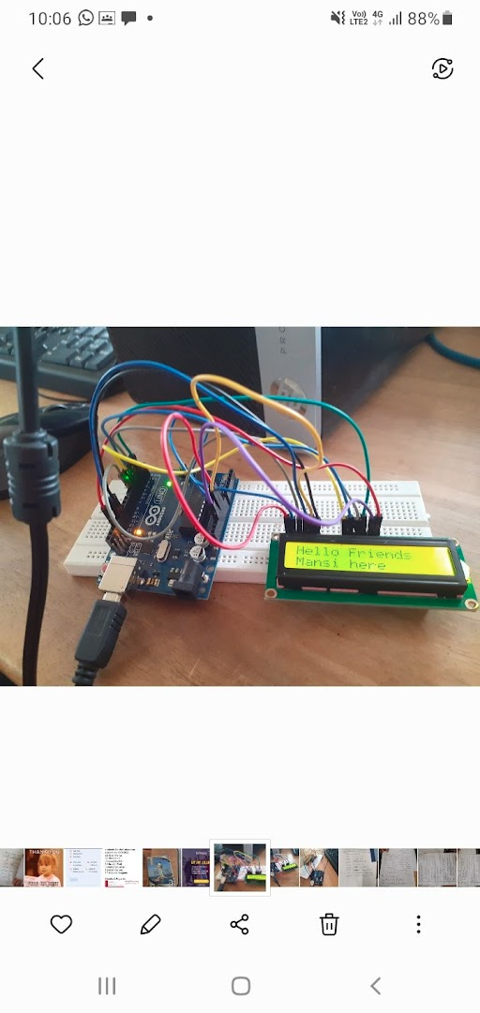

**Code:**

#include <LiquidCrystal.h>

int Contrast=75;

LiquidCrystal lcd(12, 11, 5, 4, 3, 2);

void setup()

{

analogWrite(6,Contrast);

lcd.begin(16, 2);

}

void loop()

{

lcd.setCursor(0, 0);

lcd.print("Hello");

lcd.setCursor(0, 1);

lcd.print("welcome here");

}